CHE 322

LAB REPORT

Electronic absorption spectra of tetrahedral and octahedral nickel(II) complexes

JACOB AIMINO

[JACOBAIM@BUFALO.EDU](mailto:JACOBAIM@BUFALO.EDU)

3/18/18

# INTRODUCTION:

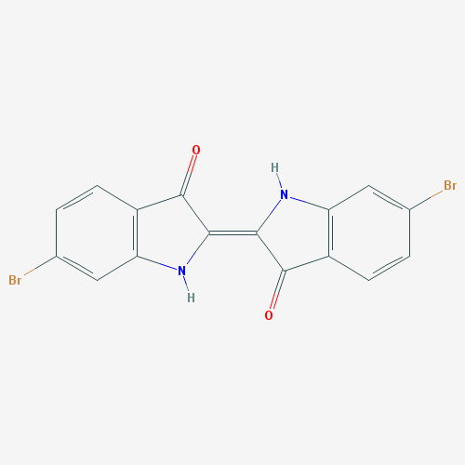

Color is a complex phenomenon that is taken for granted by many. It is what brings beauty to our world as we know it. In the past, royalties would go great lengths to acquire unique colors such as purple. Until the mid 1800s when another purple compound was accidently discovered by a chemist, the color purple was reserved for the elite due to its low supply.1 This dye was known as Tyrian purple (*Figure 1*) and to this day is prepared from a few species of mollusks found around the Mediterranean Sea. The preparation of 1 gram of pure colorant requires the hypobranchial glad of 10,000 of these mollusks.1

Figure 1: Chemical structure of Tyrian Purple (6,6'-Dibromoindigo) courtesy of pubchem.ncbi.nlm.nih.gov. CID: 5491378

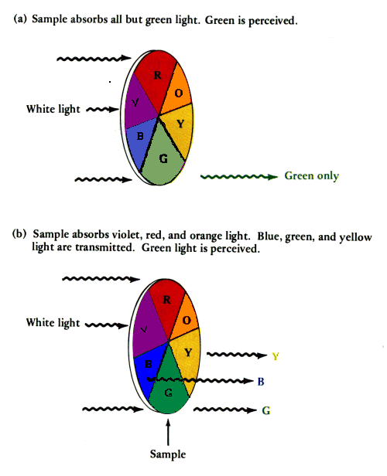Purple is a rare color in nature due to the way in which organic compounds absorb light. Typically these compounds contain aromatic or conjugated systems. The addition of electron donating functional groups (auxochromes) to these systems decreases the HOMO-LUMO energy gap allowing for lower energy photons to activate the electrons.2

When light strikes an object many things can happen affecting the apparent color of the object. Some of which include: fluorescence, luminescence, phosphorescence, refraction, interference of the reflected light, absorption, and transition through the object. 3 For this exercise, factors contributing to the apparent color of an object relating to photonic emission and interference will be ignored and only absorption, and reflection will be considered.

Figure : Color-wheel of visible light and their wavelength ranges. Credit: www.wou.edu/las/physci/

When a compound absorbs a wavelength of light, the color opposite the absorbed wavelength is reflected. The combination of the reflected wavelengths of light in the visible spectrum is what is perceived as the color of an object.1 These wavelengths and their corresponding colors are depicted in *Figure 2.*

Inorganic metal coordination complexes show many unique properties which are not seen in organic compounds. Perhaps the most notable of these would be the wide range of colors and geometries found in these compounds.4 Transition metals complexes interact differently than typical organic compounds through the recruitment of *d-d* orbital electronic transitions.4 This combined with the increase in the number of geometries that can be taken allows for these compounds to take on more colors than many organic compounds.3 The recruitment of *d­-*orbitals introduces more factors which can impact the molar absorption coefficient of the compound. These factors include forbidden electronic transitions dictated by the Laporte Selection rule and Spin Selection rule. These selection rules are not absolute and can be relaxed through vibronic coupling, spin orbit coupling, and the mixing of states. These cause the relaxation of the selection rules and allows for the transitions to occur though weakly.3

The spectra is also affected by the ligands bound to the metal center. Strong field ligands such as NH3 induce larger splitting of bands than so called weak field ligands such as halides. Weak field ligands such as Br­­- are also π-donor ligands which they are capable of ligand-to-metal charge transfer (LMCT). The bands due to these interactions tend to show high intensity in absorption spectra.5 Solvent interactions can also cause changes in the ligand field splitting energies.4 These changes are due to interactions resulting in Jahn-Teller like distortions or the orbitals. In Ni(II) chloro-complexes dissolved in dipolar aprotic solvents this spectroscopic shift was found to change as a function of decreasing donor power of the solvent.4

## Experimental Overview:

In this experiment, four and six-coordinate Ni(II) complexes were formed through a simple reaction procedure. The products were subjected to UV-Vis absorption spectroscopy for characterization of the tetrahedral and octahedral coordination complexes. This data combined with Tanabe-Sugano and Orgel diagrams were used to estimate the crystal field splitting parameter for the octahedral complex as well as the Racah parameter.

# EXPERIMENTAL PROCEDURE:

## Reaction 1: Synthesis of (Bu4N)2­ [NiBr4]

The weight of added solid was found by finding the differences in the masses of the sample on the weigh paper before and after addition to the flask. 275.1mg of anhydrous nickel(II)bromide [NiBr2] was weighed onto the weigh paper. The residual mass after addition was 6.4mg indicating a corrected mass addition of 268.7mg [Ni­Br2] to a 25mL round bottom flask. A 5.0mL aliquot of pure EtOH was added along with a flea stir bar. A condenser was attached to the flask and the combined apparatus was secured to a stand. A heating mantle connected to a variac running at 70V was the heat source. The heating mantle was set atop a hot plate for its stirring function. The reaction mixture was heated and was allowed to reflux for approximately 15 minutes. Upon completion of the reflux, any undissolved solid was extracted from the solution by vacuum filtration. The recollected solution will be referred to as ***solution 1.***

While solution 1 was refluxing, 0.6645g of tetrabutylammonium bromine [Bu4­NBr] was added to a 25mL Erlenmeyer flask and dissolved in 2.5 mL of absolute ethanol. This solution [**solution 2**] was added to solution 1 and was refluxed with stirring for approximately 15 minutes. The completed reaction mixture was subjected to rotary evaporation to remove excess solvent. The reaction 10 drops of cold CCl4­ was added to induce precipitation of solid. After 5 minutes no precipitate formed so a metal spatula was used to scrape the inside of the flask. The attempt to induce precipitation also failed. This process was repeated to no avail. After the addition of 35 drops of CCl4 precipitate formed. The precipitate was separated from the solution by vacuum filtration and washed with 25mL of CCl4. Extra solvent was used to extract all solid from the flask because the precipitate was excessively sticky and difficult to remove from the flask. Once dried the precipitate was a blue or purple color. (Note: visible color certainty is minimal due to colorblindness of the observer). Approximately ¼ of the dried product (**product 1)** was saved for spectroscopic analysis.

## Reaction 2: Synthesis of [Ni(NH3)6] Br2

Approximately 75% of the (Bu4N)2[NiBr4] (s) was dissolved in a minimal amount of deionized water in a 50mL beaker. Concentrated ammonium hydroxide was added dropwise to induce precipitation of [Ni(NH3)6]Br2 (**product 2)**. The solid was collected with vacuum filtration and washed with ice cold absolute EtOH.

## Data collection and characterization:

The preparation of product 1 and product 2 for spectral characterization by UV-Vis spectroscopy involved dissolving the products in absolute acetonitrile and 10% aqueous ammonia respectively. An operator error resulted in the dissolution of both products in 10% aqueous ammonia. Product 1 was rapidly subjected to rotary evaporation of the solvent to recover the product before complete reaction of product 1 in the solution. The resulting recovered product was gelatinous in consistency, mucous green in color, and did not resemble the initial product 1. Therefore, the product was discarded and the TA’s provided another sample of product 1 for analysis. The scanning range was set to 200-800nm and the products were diluted to 80% volume in scintillation vials to ensure a spectral maximum absorption readings of less than 1.5 units.

## Data:

Figure 4: Full UV-Vis absorption spectrum of tetrahedral complex 1 dissolved in acetonitrile.

Figure 3: Focused UV-Vis absorption spectrum of tetrahedral complex 1 dissolved in acetonitrile.

Figure 5: Focused UV-Vis absorption spectrum of octahedral complex 2 dissolved in 10% aqueous ammonia.

Figure 6: Full UV-Vis absorption spectrum of octahedral complex 2 dissolved in 10% aqueous ammonia.

# Results:

The spectra of tetrahedral [NiBr4]-2 was too difficult to read as depicted in *Figure 4*. Once the absorbance region was focus on it was evident that there was an intense wide band from 550-775 nm as shown in *Figure* *3*. Although only one band was seen on the spectrum, use of a Tanabe-Sugano diagram shows that there are 3 possible electronic transitions. The transition shown is indicative of a 3T1🡪 3T1(P). This absorbance of low energy photons would be expected due to the blue initial color of the complex. The other two transitions, 3T1🡪3T2 ­ and 3T1🡪3A2 which are lost in the IR region.

The full spectra, *Figure 6,* of the octahedral [Ni(NH3)6]2+ complex was similarly found to be unreadable. Once the absorbance region was focused on two clear peaks appeared as seen in *Figure 5* at ~350nm and ~590nm. From the Tanabe-Sugano diagram it can be concluded again that there are 3 possible electronic transitions. These transitions are: 3A2g🡪 3T2g, 3A2g🡪 3T1g, and 3A2g🡪 3T1g(P). These transitions are all spin allowed Laporte forbidden transitions. The two visible bands correspond to the 3A2g🡪 3T1g(P) and 3A2g🡪 3T1g transitions respectively. The third transition, 3A2g🡪 3T2g, therefore was lost in the IR region.

From the Tanabe-Sugano diagram one can calculate the octahedral crystal field splitting energy Δo and the Racah parameter B for [Ni(NH3)6]2+. From the diagram it was calculated that Δo ~ 10,700 cm-1 and B ~ 900 cm-1.

## Conclusion:

It is apparent through UV-Vis absorption spectroscopy that the presence of an inversion center has a profound effect on the electronic transitions allowed in Ni(II) complexes with only 1 type of ligand. The introduction of the gerade and ungerade symmetry allows for Laporte forbidden transitions which deadens the absorption signal as seen in the case of the [Ni(NH3)6]2+ which is gerade. The tetrahedral complex was found to show stronger absorbances than its octahedral counterpart due to the lack of Laporte forbidden electronic transitions.

**REFERENCES**

1. Orna, M. V., *The Chemical History of Color*. Springer: Berlin, Heidelberg, GERMANY, 2014.

2. Solomons, T. W. G.; Fryhle, C.; Snyder, S., *Organic Chemistry, 11th Edition*. Wiley: 2012.

3. Miessler, G. L., Paul J Fischer, and Donald A Tarr, *Inorganic Chemistry*. Pearson: 2014; Vol. Fifth Edition.

4. Chiboub-Fellah, A.; Meullemeestre, J.; Spies, C.; Vierling, F.; Khan, M. A., Octahedral and tetrahedral configuration changes of nickel(II) chloro complexes from spectrophotometric studies in aprotic solvents. *Transition Metal Chemistry* **1999,** *24* (2), 135-140.

5. Barreto, W. J.; Ando, R. A.; Santos, P. S.; Silva, W. P., Preparation, UV–vis, IR, EPR and resonance Raman study of Fe, Ni, Co and Zn dioxolene complexes. *Spectrochimica Acta Part A: Molecular and Biomolecular Spectroscopy* **2007,** *68* (3), 612-618.